**.NET Application Programming**

**Project Status and Design Report**

|  |  |  |
| --- | --- | --- |
| **Topic:** | Milestone2 | |
| **Date:** | 1/29/18 | |
| **Revision:** | 2.0 | |
| **Team:** | 1. William Bierer | |
| 2. Stuart Reeder | |
| **Weekly Team Status Summary:** | |  |  |  |  | | --- | --- | --- | --- | | **User Story** | **Team**  **Member** | **Hours**  **Worked** | **Hours Remaining** | | *Make the views and controllers for Logging in and Registering. Updated design report* | *Will Bierer* | *12* | *0* | | *Made the database for the application. Created the UserModel, Created error messaging for the forms. Updated Design Report* | *Stuart Reeder* | *10* | *0* | |  |  |  |  | |  |  |  |  | |  |  |  |  | |  |  |  |  | |  |  |  |  | |  |  |  |  | |  |  |  |  | |  |  |  |  | |  |  |  |  | |  |  |  |  | | |
| **GIT URL:** | https://github.com/wbierer/CST-247_Bierer_Reeder | |
| **Loom URL:** | https://www.useloom.com/share/a1fa1c72272d499694b49dfa05344235 | |
| **Peer Review:** | *Yes* | We acknowledge that our team has reviewed this Report and we agree to the approach we are all taking. |

**Planning Documentation**

**Agile Scrum Product Backlog:**

|  |  |  |  |  |  |  |  |
| --- | --- | --- | --- | --- | --- | --- | --- |
|  |  |  | User Stories | | |  |  |
| ID | Feature | User Story | As a(n) <actor> | I would like to <description> | So that <outcome> | Priority | Sign-off Date |
| S2 | Game Board Pages | 1 | As a User | See the gameboard after I log in | I can play minesweeper | 1 | 2/11/18 |
| S2 | Backend Services for game logic | 2 | As a User | Play Minesweeper | I can play the game | 1 | 2/11/18 |
| S2 | Update Database | 3 | As an administrator | Have all the user data stored | I can Manage the users | 1 | 2/11/18 |
| S3 | AJAX Forms/Partial page updates | 1 | As a User | Be able to play the game without refreshing the page every time i click the board | The game plays more fluidly | 2 | 3/11/18 |

**Agile Scrum Sprint Backlog:**

|  |  |  |  |
| --- | --- | --- | --- |
| User Story ID | User Story | Task | Assigned To |
| 1 | As a Site User I need to be able to login to the site with my account | Create Login View | William Bierer |
|  |  | Create Login Controller | William Bierer |
|  |  | Create Error messaging for the login page | Stuart Reeder |
|  |  |  |  |
| 2 | As a Site User I need to be able to create an account for the site | Create Registration View | William Bierer |
|  |  | Create Registration Controller | William Bierer |
|  |  | Create Error Messaging for the Registration page | Stuart Reeder |
|  |  |  |  |
| 3 | As a Website Administration, I want to be able to store all the user information and access it when neccessary | Create a User Model | Stuart Reeder |
|  |  | Create a Database for the website | Stuart Reeder |
|  |  | Create a database table that contains user information | Stuart Reeder |

**Agile Scrum Burn Down Chart:**

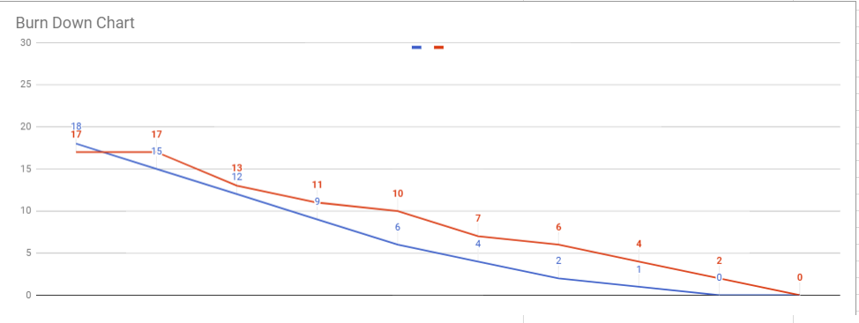

Blue- Ideal Red- Actual

**Agile Retrospective Results:**

*Laying out what we need to be working on for our upcoming sprint is very helpful. Although we need to make sure we keep updating the burn down chart as we work through a sprint. Being on top of what we have planned out on our sprint is very helpful in the end.*

|  |
| --- |
| **What Went Well** |
| Our application met all of the requirements of this milestone |
| We were able to create error messaging for all of our forms |
|  |

|  |  |  |
| --- | --- | --- |
| **What Did Not Go Well** | **Action Plan** | **Due Date** |
| We didn’t allocate enough time to the design report throughout the sprint. This caused us to have to submit late | Dedicate more time to the Design report during the next sprint |  |
| Our login forms are not case sensitive. | Spend time figuring out how to fix this and get it fixed by next Milestone | Next Milestone |
|  |  |  |

**Design Documentation**

**Install Instructions:**

*Acquire the project code from either zip package or the git repository. Install onto your version of Microsoft Visual Studios. Set up the Database using the DDL Script. Run the project through visual studios server on your localhost.*

**General Technical Approach:**

* Minesweeper Web application
  + Login/Registration system
    - Registration includes: First Name, Last Name, Sex, Date of Birth, State, Email, Username, and Password
    - Cannot play minesweeper unless user is logged in
  + Home page will have game board on it
    - User can play the game
    - User can save game states
    - User can load a game state to continue their progress.

**Key Technical Design Decisions:**

* Registration Requires: First and Last name, Username, Password, Email, Sex, Age, and State.
* AJAX will be used to have partial page updates so the entire page won’t refresh when the user makes a move.
* Bootstrap plus custom stylesheets will be used to make the site look profesional

**ER Diagram:**

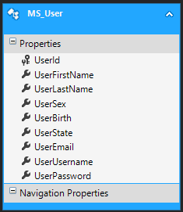

**DDL Scripts:**

*DB file can be found in the app_data directory*

***Sitemap Diagram:***

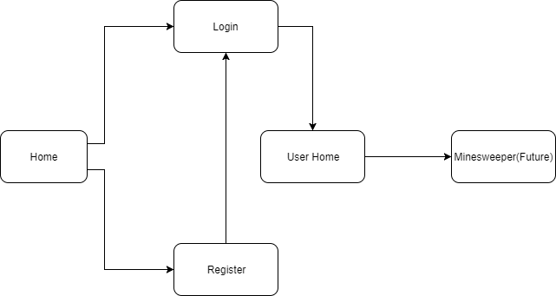

**Security Design:**

*N/A*

**Flow Charts:**

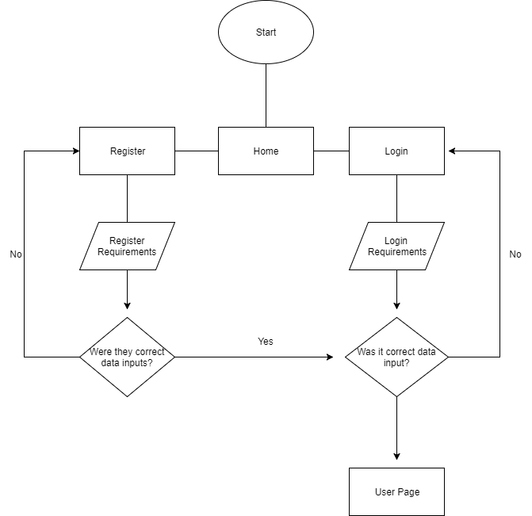

**User Interface Diagrams:**

Home Page

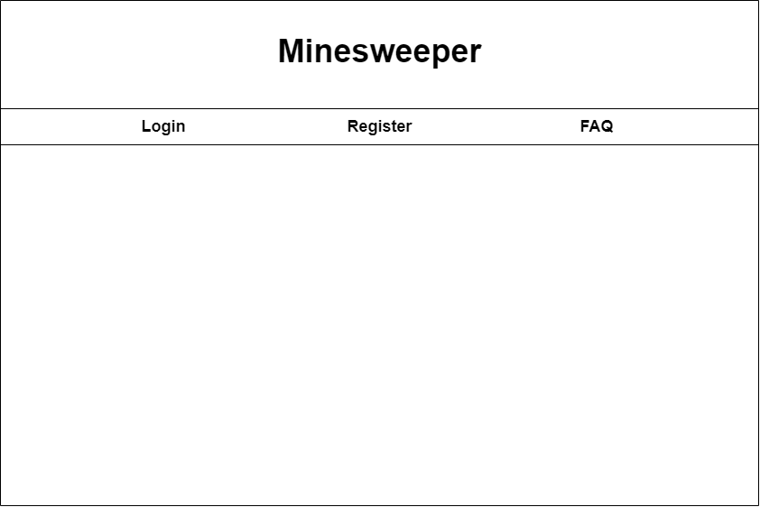

Register Page

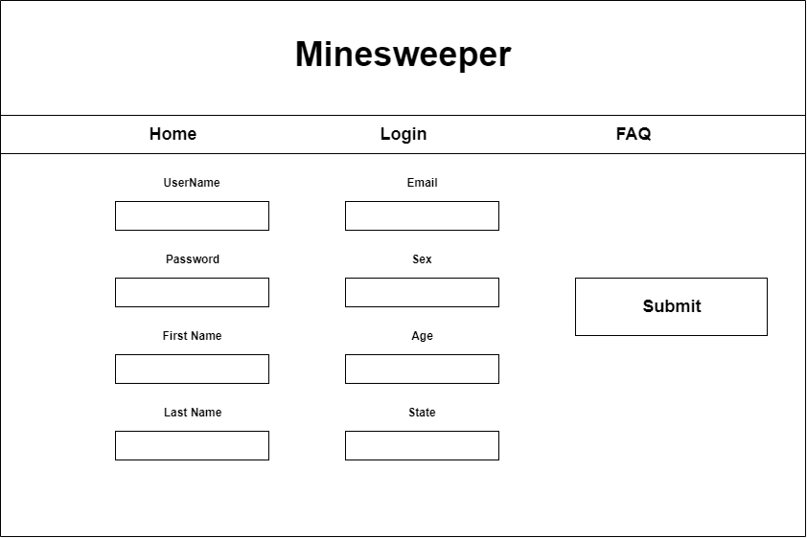

Login Page

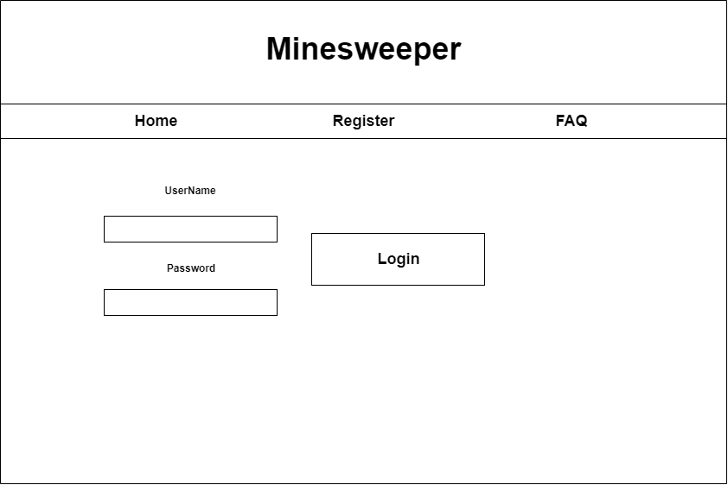

**Class Diagrams:**

